1. 
2. **Agenda**:
   1. How to work with hash table in Java.
3. 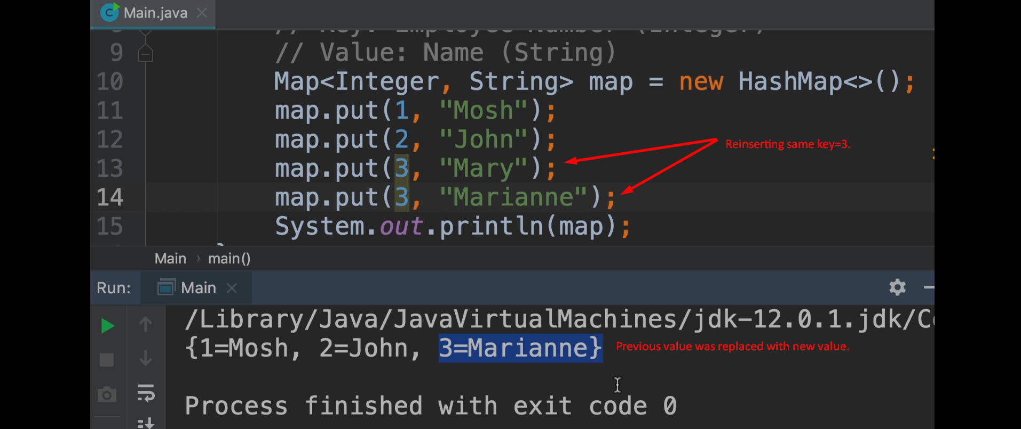
4. 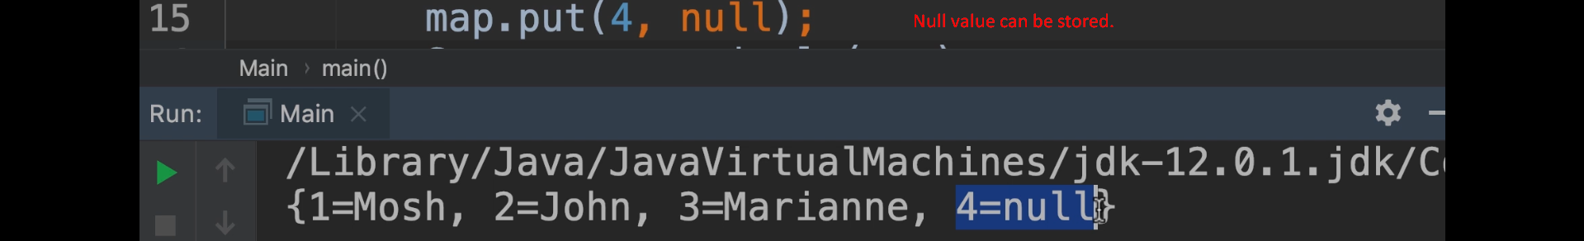
5. 
6. 